## Lab Report : 07

## Lab Report Name: Implementation of FCFS Scheduling Algorithm.

## ID : IT-18016

**Objective:-** To understand the first come first serve (FCFS) scheduling algorithm technique in detail.

To simulate First Come First Served (FCFS) Scheduling Algorithm using C/C++.

To understand the advantage and disadvantage of first come first serve (FCFS) scheduling algorithm technique.

**FCFS:-** First come, first served(FCFS) is an operating system process scheduling algorithm and a network routing management mechanism that automatically executes queued requests and processes by the order of their arrival. With first come, first served, what comes first is handled first; the next request in line will be executed once before it is complete. FCFS is also known as first-in, first-out (FIFO) and first come, first choice (FCFS).

Given n processes with their burst times and arrival times, the task is to find average waiting time and average turn-around time using FCFS scheduling algorithm.

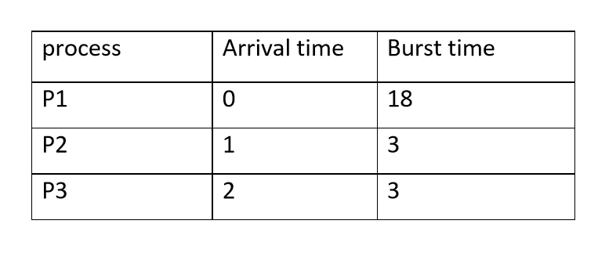

FIFO simply queues processes in the order they arrive in the ready queue. Here, the process that comes first will be executed first and next process will start only after the previous gets fully executed.

1. Completion Time: Time at which process completes its execution.
2. Turn Around Time: Time Difference between completion time and arrival time. Turn Around Time = Completion Time – Arrival Time
3. Waiting Time (W.T): Time Difference between turn-around time and burst time. Waiting Time = Turn Around Time – Burst Time.

Gantt chart:

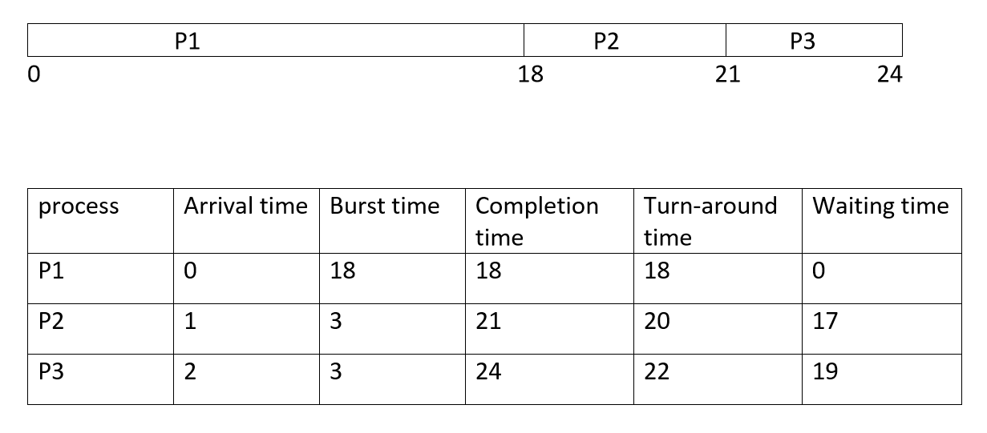

Average waiting time = (0+17+19)/3

=12ms

Average turn-around time = (18+20+22)/3

=20ms

**Code:-**

#include<stdio.h>

findWaitingTime(int pro[],int n,int burst[],int wt[],int ar[])

{

int i=1;

wt[0]=0;

burst[0]=0;

ar[0]=0;

while( i<=n)

{

wt[i]=burst[i-1]+wt[i-1]+ar[i-1]-ar[i];

i++;

}

}

findTurnAroundTime(int pro[],int n,int burst[],int tat[],int wt[])

{

int i=1;

while(i<=n)

{

tat[i]=burst[i]+wt[i];

i++;

}

}

findavgTime(int pro[],int n,int burst[],int ar[])

{

int wt[n],tat[n],total_wt=0,total_tat=0,i=1;

findWaitingTime(pro,n,burst,wt,ar);

findTurnAroundTime(pro,n,burst,tat,wt);

printf("Processes Burst-time Waiting-time Turn around-time \n");

while(i<=n)

{

total_wt=total_wt+wt[i];

total_tat=total_tat+tat[i];

printf("%d\t",i);

printf(" %d\t\t",burst[i]);

printf(" %d\t\t",wt[i]);

printf(" %d\n",tat[i]);

i++;

}

float s=(float)total_wt/n;

float t=(float)total_tat/n;

printf("\nAverage waiting time = %.3f\n",s);

printf("\nAverage Turn Around time=%.3f\n",t);

}

int main()

{

int n;

printf("number of processes= ");

scanf("%d",&n);

printf("process arrival Brust\n");

int pro[n],burst[n],ar[n],i=1;

while(i<=n)

{

scanf("%d",&pro[i]);

scanf("%d",&ar[i]);

scanf("%d",&burst[i]);

i++;

}

findavgTime(pro,n,burst,ar);

return 0;

}

**Output:**

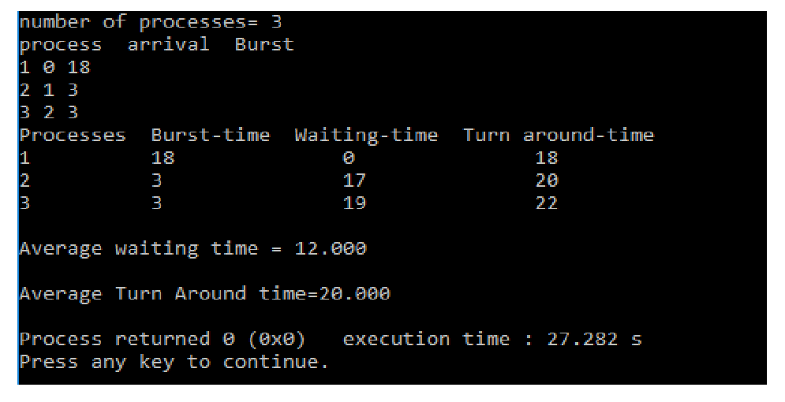

**Conclusion:-** This algorithm is about first come first serve (FCFS) scheduling algorithm technique. The main characteristics of first come first serve (FCFS) scheduling algorithm technique are that they are Non-preemptive, ready queue just a FIFO queue, careers coming are positioned at queue’s end, dispatcher selects job in this work and line works to end of CPU burst.